Week 3 Research- Brandon Early
- Still not sure where to get any funding for more Arduino’s, the REU web page on MTU’s website isn’t very clear. I can’t even figure out who I should maybe email about that? If the patent went through, we should ask around, I might be able to get my Enterprise Advisor to help explain some stuff, he is an advisor for another REU project

Communication
- Focusing on wired communication for now, wireless is probably more real world applicable, but for the sake of the prototype/proof of concept:

Wired
- There are a few options
- UART
  - This is serial communication, transmitting one bit of data at a time, using 2 dedicated ‘send’ and ‘receive’ pins
  - Serial communication will be fairly slow; however, this does allow for direct device to device communication
  - Distance is the biggest factor here, at ranges past ~1 meter its incredibly unreliable, but perhaps it could be combined with a longer-range protocol to solve that problem?
  - For the prototype at least, the distance limitation isn’t such a big deal though
- I2C
  - Inter-integrated circuit, I have some minor experience working with this one
  - Uses two data lines to connect multiple devices onto one bus, (useful in our case for the ‘current’ node being connected to both ‘previous’ and ‘next’ neighbors).
  - This does have a ‘master-slave’ setup though, I don’t know if that will affect the inter-node communication while ensuring that there is no ‘central’ controller.
  - Still quite slow, and isn’t great over distances, I would have to do some testing, but I imagine much farther than ~1 meter would start to be sketchy
- RS-485
  - Differential Serial Communication
  - Robust, and supports long distance communication (!!!)
  - Allows for multiple devices on a single bus, which again is essentially a must for this project.
  - This does require a transceiver IC, they are moderately expensive ~$6.30 individually
  - Very resistant against noise, which is a big plus considering the nodes are intended to be used outdoors, in unstable environments
  - This would be a more complex choice from a software/programming side of things from what I can tell, but all the hardware benefits might make it worth it
  - Potentially ‘overkill’ for the prototype, maybe worth looking into/combining with UART for a real-world solution?
- CAN
  - Message based, this is the protocol used in cars which could maybe be a feature to consider (if we ever wanted the nodes and the cars driving on the road to be communicating this would be the easiest way to do it, but I’m not sure if it’s possible to have: nodes communicate through one protocol, and node-to-car on CAN protocol, that is a problem for the future :D )
  - This also requires additional hardware- controller and receiver for each node, again Digi Key has them individually for ~$.83
  - I think this might be a little overkill or potentially defeat the purpose of the ‘no central controller’ idea of our project though, as I mentioned above, maybe for future communication with the cars themselves but for the nodes might not be the best option
  - Also, more complex on the software/programming side
- Wired Summary
- UART, I2C and RS-485 are by far the best choices at this stage of the project.
- The other protocols either don’t provide the features we need or aren’t suited to meet the long-term goals of the project (i.e. moving past a prototype into a real solution).
- I2C is the more straight forward and well documented communication method, but the short distance, and master-slave setup make it only feasible for prototyping and since I would like to try and keep the prototype as scalable to a potential final product as possible, I’ve chosen not to pursue I2C.
- RS-485
  - As mentioned above, great for long distance communication, allows for multiple devices on the same bus (meaning we can have the current node communicating with both the previous and the next node) and is resistant to noise (which will be especially important for a node in an extreme outdoor environment).
  - Uses differential signaling
    - Differential signaling
  - Each Arduino needs additional hardware, some sort of RS-485 transceiver, to both send and receive data (these seem to run for ~$6 individually, which admittedly is moderately expensive).
  - Half-duplex communication
    - This means one node can talk, the other can listen, they can’t talk and listen to each other simultaneously, the crucial detail though, is communication can go both ways, just not at the same time.
  - The biggest Hurdle: No defined protocol
    - This means there is no predetermined addressing or something similar, as I2C would already have.
    - This will undoubtedly be a challenge to implement but is still possible.
    - Designing the protocol will undoubtedly require some more information on exactly what information is important for each node to communicate, as well as what the best way to design the protocol itself might be
    - Trying to stay away from a ‘single master’ concept means we must determine the best way to define the protocol such that communication between adjacent nodes is straightforward.
  - One of the biggest pros of this is the speed and distance possibilities
    - RS-485 supports distances of up to 1200 meters, which obviously is a bit overkill (the average lane marking in the US is ~9 meters apart from the next one)
    - However, at short distances, transmission speeds are fantastic: Mbps
- UART
  - Avoids using one common bus between all nodes, this allows for truly localized communication. So, when one node receives sensor readings, only its neighbors would know at all, some node far away wouldn’t know about it and just be programmed to ignore it, it would never know at all.
  - Also allows for multi-directional communication (simultaneous?)
  - Established protocol that should help make the programming, debugging and general understanding/explanation of the project straightforward. Prototypes won’t need long distance communication, so this protocol is safe at ranges of .5 meters, as described in the project proposal.
  - At distances of ~.5 meters, using jumper cables starts to become a pain, but the plus side is that essentially any cheap wiring should do the job at that range (maybe investigate this more, see if there is a clear benefit to a specific type of wire)
  - I think this is the correct choice for prototyping at least

UART Wiring Information and Diagram
- PWM 0-1 are the UART send/receive pins
- Rx
  - This is the receive pin
- Tx
  - This is the transmit pin
- All nodes also will need a common ground
- Both Arduinos must be on the same baud rate
- Probably going to be a challenge to power the boards separately from the USB?
  - Note: USB power is not necessary for sketch to stay on board, I can upload a sketch, unplug USB, power the board elsewhere, and there will be no issue
  - Battery power information is relevant here, but for organizational purposes I’ll talk about it in the power section.
- There is one bit of a caveat for Arduinos at least, because there is only 1 Tx and Rx pin per board, we have to get a little creative to implement nodes that need to transmit data to both the ‘previous’ and the ‘next’ node.
  - Luckily, we can use digital I/O pins as simulated ‘software’ UART pins. This is a suitable solution for the prototype, although not perfect, it should more or less do the job.
  - The software pins obviously would have to be defined in the code.
  - The need for physical pins is a fantastic example of why wireless communication is superior for a finished product.
- So, that being said: rough diagram for a node connected to both previous and next nodes: 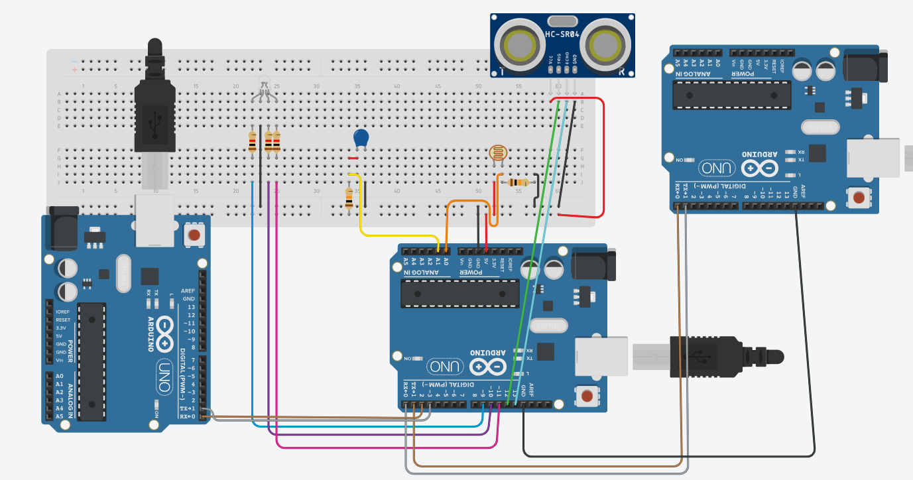
  - Note that obviously I don’t have sensors hooked up to the other 2 nodes

Wireless
- There are probably just as many options for wireless communication as there are for wired.
- It should go without saying that this information is certainly more relevant to at least future prototypes, if not the final product, however it’s still important to consider the available options.
- RF modules
  - These are about as primitive as it gets, it’s essentially just radio waves
  - Usually SPI based, which means there will be some documentation/prior examples of this kind of communication being done
  - Another positive of this option is power consumption; RF requires incredibly low power.
  - The modules are generally cheap as well, allowing for easier large-scale production
  - Works just fine with the ‘localized’ communication we want to implement.
- Bluetooth
  - This one is a good option
  - There is a LOT of documentation and support for Bluetooth which would be very nice.
  - It is very power efficient, which is an important plus
  - There is also fairly good range, although I need to dig deeper into quantifying that, I’m sure that outdoor environments will shorten the range, but I don’t have numbers at the moment.
  - I also want to find out more about the ‘multi node’ connection possibilities. I’ve never worked with a Bluetooth device that could connect more than two things at once, which is what we probably need
    - Further research revealed that peer-to-peer localized communication through Bluetooth would be extremely challenging/awkward
    - It has a similar ‘master-slave’ setup like I2C does for wired communication
- WIFI
  - This is another interesting option
  - It has a lot of the same perks as Bluetooth, however it also has some added benefits and drawbacks
  - One plus is that the data rate is MASSIVE, there would be no struggles communicating what we need to, and there would be plenty of room for future improvements or added features, but the flipside to that argument is that its overkill for our project
  - The major downside is power consumption, WIFI is incredibly power hungry, and with the nodes being powered likely by solar, I am not sure there is a smart way to implement this
- LoRa
  - Long range, radio based communication
  - This one might have a few small hurdles in setting it up for localized communication, but the other upsides are great.
  - Has tested, long range capabilities in outdoor conditions
  - Low power consumption
  - There are some challenges in terms of data rate, it is extremely slow compared to some of the other options, but its also generally ‘event driven’ which makes it well suited to the goal of having the nodes be essentially dormant when they aren’t needed.
- There are some other options, but after looking at them even just briefly, I don’t think they really suit the project well.
- Summary
  - After some further consideration and review of the information above, I think that some form of RF module is the smartest, most straightforward way of wireless communication. A bonus is that the general concepts involved in implementing this shouldn’t be all that different from UART and the wireless prototype.

Power
- As far as I can come up with, there are two real options here, either battery powered or solar power (although I guess you could combine the two to charge a battery?)
- Some key questions:
  - How much power does solar alone actually create? That is the key bottleneck here
    - It would be fantastic if, in addition to additional Arduinos, we could get a cheap, small solar panel I could test the output of, then scale the results.
  - Is battery power even feasible?
    - With the idea of the project being that these nodes are more or less ‘set and forget’ I think that having them be battery powered and requiring batteries to function defeats that purpose.
      - Unless they are recharged with solar
  - What is the safest option from both a power and road safety standpoint?
- Additionally, in order to get a full scope of the answer to the battery vs solar question, I think having or assuming some sort of baseline power draw from the device will be necessary, but maybe for prototype/preliminary testing it is feasible to power it through USB while getting readings on roughly how much power is being used for each sensor/LED.
- To paint a picture of the general idea however, I believe, and fully expect that solar readings will provide strong enough evidence for it to be the leading source of power generation/supply for the final product.
- For proof of concept however, I may choose to (again parts permitting) create a small ‘charging’ circuit using a small solar panel to simulate a more polished version of the project using solar power to charge a battery which in turn powers the rest of the system.
- The biggest issue in using solar power exclusively for the prototype is the Arduino. Some quick google searches tell me that on average it draws 45-70 mA while idle, which is simply too large of a number for testing/working on the prototype.

Battery Power
- Some additional research has given me some new perspectives on powering the prototype via battery, and I now think that it is more possible than I previously believed.
- The Arduino can be powered by an external source through the Vin and Power GND pins on the board.
  - The Vin pin has an internal voltage regulator to scale the voltage it receives down to 5V, the expected voltage is ~7-12V, so a 9V battery is probably the best choice for power for the prototype, as they are relatively cheap and easy to access.
  - Further versions of the project would likely want a Lithium-Ion battery or something similar.
  - Something else to keep in mind, is that while we can take advantage of the internal regulator for the prototype, eventually, if (and probably when) we get rid of the Uno R3, in favor of a smaller, less power hungry board, there is a chance we would have to design/make use of an external voltage regulator.
- This also means that the need for some sort of ‘charging’ circuit from a solar panel would be essential, and I can look into that a lot more next week.

Power Vs. Communication
- One of the biggest concerns I have at this point is power consumption in general. While it isn’t a huge deal for the prototype, which is being powered by USB, eventually power consumption will be a critical factor of the project.
- As such I want to get a rough idea of how ‘power hungry’ the ideal communication protocol we have for the prototype, as well as the projected longer-term solution, are.
  - The good news is the UART itself is fairly low power consumption, with estimated 1-2 µA while UART on an Arduino is idle, and just 100-300 µA while actively transmitting.
  - This means that certainly for the prototype at least, power consumption from purely communicating will be minimal!
  - Notably, this will change a bit for a more practical version of the project, which would ideally most likely have wireless communication of some sort and as such would be more power intensive.

Microcontroller VS FPGA
- One thing I have noticed while doing much of the research about both power and communication protocols is that while microcontrollers can make some things straightforward/easy, they also come with the hefty downsides of requiring much more power, as well as their huge form factor.
- As a result, I am interested in the use of an FPGA or something similar being used to ‘control’ each node, rather than a microcontroller
- Some initial research provides enough insight into this problem:
  - First of all, it should be noted that an FPGA could do the task at hand here, that isn’t the issue
  - The problem lies more in what exactly we need the device to do, which, both in the prototype, and a finished product is:
    - Take reading from sensors
    - Communicate with local neighbors
    - Control an LED
    - Limit power consumption (probably going ‘idle’ or ‘sleep mode’ to do so
  - FPGAs, while capable of doing all these things in one way or another, are not as suited for most of them as a microcontroller would be
  - The most drastic drawbacks include power consumption and cost.
    - While cost isn’t as big a deal for the prototype, eventually, to be useful this project would need to be many nodes, so cost should be a factor to keep in mind.
    - Power consumption is the big drawback from what I can tell. As far as I can see, there isn’t really a kind of sleep mode for an FPGA, so even while the node is doing nothing, it is drawing a LOT of power, which is especially a concern when the most likely power source for the device is solar.
- So with the FPGA vs Microcontroller issue laid out, I think looking into some more realistic options outside of an Arduino could be for a long term, to finished product version of the project.

Wishlist
- At least one more Arduino (ideally 2-4 more though)
- Cheap Wiring, ~5 feet or so should be PLENTY
- Small solar cell to test solar power generation/battery charging
- PIR sensor to test and compare to the ultrasonic sensor

